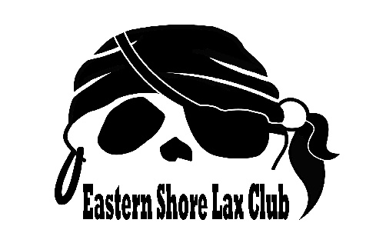
SENDING EMAILS TO COLLEGE COACHES:
Remember:
- Write in each specific coaches name and include the entire coaching staff
- Include a personal touch (a game you watched, a big win they had, a player you know on the team, why you like their school, program, etc)
- Include your student athlete resume
- Include the name + location of where you will be playing
- Include your club name, upcoming schedules, field nubers, jersey number and color
- Thank them for their time
- Follow up! College coaches receive A LOT of emails. If you are interested in a school, keep the coaches updated every 2-3 months.

Sample Emails:
Subject Line: Name Class of 2011 Midfielder
Coach ______,
I am attending the Disney Showcase with my club team, Delaware Shore and I'm hoping you might be able to watch me play. I am very interested in your program at Louisville. I watched you beat Michigan in the second round of the NCAA tournament, and I loved the way your team came from behind and played tough circle defense.
I am a sophomore (grad year 2011) at Cape Henlopen High School in Lewes, DE. I play for Coach Nicole Catanzaro who speaks very highly of you and your program. I've been selected as a Futures Elite player for the 2008-09 year, and I've been a National Futures Selection for the last three years. This summer I attended the Jr. Olympics and played for Jeremy Cook (Bucknell); it was awesome, and we won the Bronze Medal! I was also named Second Team/All Conference for my high school. Again, I will be playing at Disney for my club team Delaware Shore. I wear number 3 and play the midfield.
DE SHORE SCHEDULE
Friday 11 am Field 11
Friday 3 pm Field 9
Sat. 10 am Field 1
Sat. 4 pm Field 10
Sat. 9 pm Field 3
My contact information is: email: email@msn.com, home phone: 302-000-0000, cell phone: 302-333-2222
address Lewes, DE 19958
Thank you so much. I hope you get the chance to watch me play.
Subject Line: Name Class of 2011 Midfielder
Coach Bozman & Coach Martin,
I just wanted to update you on my season. We won a battle last night against St. Marks winning 1-0. We will be playing Wednesday, November 18 against our cross-town rivals, Sussex Tech (#3), in the state semi-finals! We were the second seed in the Delaware State Tournament with a season record of 14-0-1. Cape was the Henlopen Conference Champ, and I was a First Team, All Conference Selection.
I will be playing at festival with my travel team, Delaware Shore. We are in Pool D, and I wear jersey number 3.
Our schedule is as follows:
POOL D/DELAWARE SHORE SCHEDULE
THURSDAY
1:00 pm FIELD 15 vs. East Coast Lightning
3:00 pm FIELD 17 vs. CNY
FRIDAY
9:00 am FIELD 22 vs. Polar Bears
3:00 pm FIELD 15 vs. Mystx Stealth
SATURDAY
7:00 am FIELD 23 vs. Team Michigan
10:00 am FIELD 11 vs. Lanco Premier
Thank you and please let me know if you would like any other information.
Subject: Name Class of 2011 midfielder
Hi Coach Shelton,
I wanted to update you on my summer hockey activities. I am still very interested in UNC's hockey program.
I will be attending the National Futures Championships in Virginia Beach for the fourth consecutive year. I will be playing for the u19 team RICHMOND.
I will also be playing in the Focus College Showcase at the Warhill Sports Complex in Williamsburg, VA on Wednesday, July 1. My team name for the Focus Showcase is Delaware Shore and I wear #3. I hope you will be at one of these events and get a chance to see me play.
I attended the Futures Invitational Camp held at Wake Forest over Memorial Day weekend.
I have previously sent you my resume, but it is attached again with my most recent accomplishments. Thank you very much.
Name
email@msn.com
302-333-3333 (cell)
address
Lewes, DE 19958

